## MUAC (Mid-Upper Arm Circumference) indicator and climate data: correlations

* Gifs of MUAC against precipitation and its lags
* Each image of gif presents one lag
* Correlation dies out with increasing lag
* ASAL counties, 2013-2017, monthly data
* MUAC from the NDMA bulletins



* According to correlation coefficients, MUAC and precipitation highly correlated
* Also MUAC and the lags of precipitation highly correlated

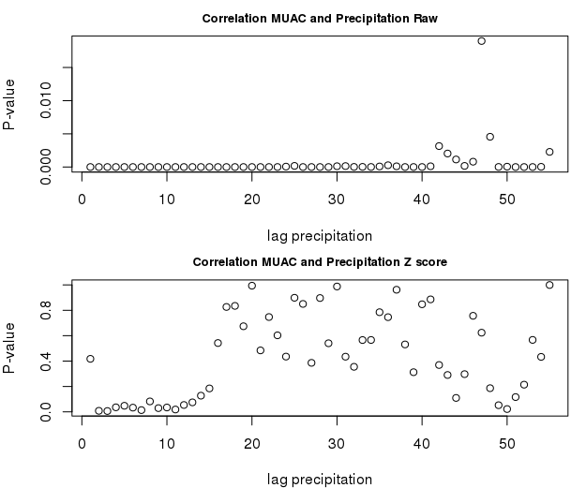

* For the raw precipitation (the upper picture above) , the correlations highly significant for all lags except one
  + This could be due to the county specific effects
* The p- values relatively higher for lag 40 and more
* For the Z score of precipitation, the correlation stops being significant for lags around 10 and more
* **Coping Strategy Index (CSI)- interesting point:** the correlation between CSI and z score of precipitation only starts to be significant at lag 4 of the precipitation.
  + Hence, the coping strategies are only significant after 3 months of drought (in terms of z-score of precipitation)

### Mixed effects models

$M_{i,t}=α+α_{i}+β^{P1}P_{i,t-1}+β^{P2}P_{i,t-2}{+β}^{P3}P_{i,t-3}+β^{P4}P_{i,t-4}+β^{P5}P_{i,t-5}+β^{P6}P_{i,t-6}+...$

$...+b_{i,t-4}^{P4}P_{i,t-4}+b_{i,t-5}^{P5}P_{i,t-5}+b_{i,t-5}^{P6}P_{i,t-6}+u_{i,t}$

i...County

t...Month

Mi,t… % of children under 5 with Mid-Upper arm circumference (MUAC) < 135mm

𝛂… Intercepts

Pi,t...Z-score of precipitation (median) in county i, month t

Ti,t...Z-score of temperature (median), in county i, month t

𝛃...Slopes - fix effects

b...Slopes - random effects

|  |  |
| --- | --- |
| Fixed effects | Estimate |
| Precipitation z-score, median, lag 1 | -0.743*** |
| Precipitation z-score, median, lag 2 | -0.603*** |
| Precipitation z-score, median, lag 3 | -0.373* |
| Precipitation z-score, median, lag 4 | -0.571* |
| Precipitation z-score, median, lag 5 | -0.847** |
| Precipitation z-score, median, lag 6 | -1.047*** |
| Precipitation z-score, median, lag 6 | -0.342** |